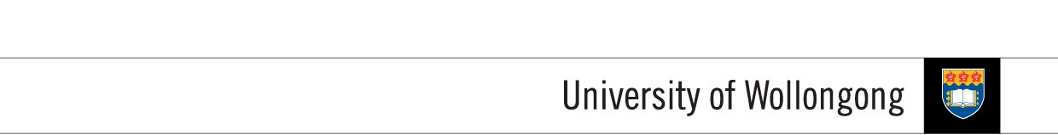

**FACULTY OF INFORMATICS**

|  |  |  |  |
| --- | --- | --- | --- |
| **SUBJECT’S INFORMATION:** | | | |
| Subject: | CSCI124 Applied Programming | | |
| Session: | July 2014 | | |
| Programme / Section: | J766SENG (SE) / J766CS53 (MGD) / J766CS42 (DSS) | | |
| Lecturer: | Ms. Siti Hawa | | |
| Coursework Type  *(tick appropriate box)* | ❑ Individual Assignment ❑ Group Assignment ❑ Project  ✓Lab Task ❑ Seminar / Tutorial Paper ❑ Others | | |
| Coursework Title: | **Lab Task 5** | Coursework Percentage: | 2% |
| **ASSESSMENT CRITERIA:** | | | |
| Correctness | All programs should produce the correct result as stated in the specification. | | |
| Coding | Programs should use appropriate control structures and data structures correctly based on what have been covered in the class and stated in the specification. Necessary input validations should be done. | | |
| Readability | Appropriate comments are included. Meaningful identifiers used. Proper indentation and line spacing used. | | |
| Well formatted output | Output should be well formatted with appropriate messages displayed. Numbers are shown with appropriate precision. | | |
| **SUBMISSION:** | | | |
| All completed work should be submitted online through Moodle before or on the due date provided.  **SUBMIT AS EARLY AS POSSIBLE. YOU CAN RE-SUBMIT LATER IF NECESSARY. ONLY THE LATEST SUBMISSION WILL BE MARKED.**  **IF YOU SUBMIT YOUR ASSIGNMENT TWICE, ONE SUBMMISSION BEFORE THE DUE DATE AND ANOTHER AFTER THE DUE DATE, THEN YOU WILL BE PENALIZED FOR LATE SUBMISSON.** | | | |
| DUE DATE: | **WEEK 7** | | |
| **PENALTIES FOR LATE SUBMISSION:** | | | |
| Penalties apply to all late work, except if student academic consideration has been granted. Late submissions will attract a penalty of 25% of the assessment mark per day including the weekend. Work more than (3) days late will be awarded a mark of zero. | | | |
| **PLAGIARISM:** | | | |
| **When you submit an assessment task, you are declaring the following**   1. It is your own work and you did not collaborate with or copy from others. 2. You have read and understand your responsibilities under the University of Wollongong's policy on plagiarism. 3. You have not plagiarised from published work (including the internet). Where you have used the work from others, you have referenced it in the text and provided a reference list at the end ot the assignment.   Plagiarism will not be tolerated. Students are responsible for submitting original work for assessment, without plagiarising or cheating, abiding by the University’s policies on Plagiarism as set out in the University Handbook under University Policy Directory and in Faculty handbooks and subject guides. | | | |

**COURSEWORK SPECIFICATION**

**OBJECTIVES:**

This lab task will provide you with the experience of working with pointers and pointer arithmetic.

**TASKS**

Write a program that calls the following functions:

* A function that accepts as arguments an array of integers and an integer that indicates the number of the elements in the array. The function should determine and return the mode of the array. The mode of a set of values is the value that occurs most often or with the greatest frequency. If the array has no mode (none of the values occur more than once), the function should return -1. You may assume that the array will always contain nonnegative values.
* A function that accepts as arguments an int array and an integer that indicates the number of the elements in the array. The function should determine and return the median of the array. When a set of values is sorted in ascending or descending order, its median is the middle value. If the set contains an even number of values, the median is the mean, or average, of the two middle values. The value should be return as a double. You are required to use a temporary array for the sorting. The original array should not be changed.
* A function that accepts an int array and the array’s size as arguments. The function should reverse the content of the array.

For this task, you are required only to use the pointer notation instead of array notation.